Presenting your Boat
Like a house, or a car, boats will always sell more easily if they are well presented and made to look visually appealing. That is not to suggest any attempt to mislead a potential purchaser, in fact we operate a ‘warts and all’ policy, with damage and defects being shown with as much detail as any other aspect of the boat. Remember people will often be travelling considerable distances to view and your prospects of attaining your target price will be severely dented if the potential buyer finds the boat is not as advertised.
For full brokerage we will undertake the photography, but for Remote Brokerage, we will need you to provide some good quality images – a mobile phone camera is sufficient.
You will be surprised how many images you will need.
If you can, it is worth taking short videos as well of most of the points below – a series of short videos is preferable to several longer ones – Landscape videos and images are preferrable, however fully rigged portrait images are fine.
1. Uncover the boat and empty it of all extraneous items. (Make sure the boat is clean)
2. Be aware of the background that may appear in the images and videos and move the boat to a suitable spot if possible.
3. Rig it fully.
4. Take several portrait and landscape pictures of the boat – some with the full mast and hull in view, others with close ups of sails to shown makers name, degree of fading, general condition, any repairs or areas that need repair. Make sure you include sprayhoods up and down if applicable.
5. Using a step ladder to give a good angle, take pictures from bow and stern, whilst fully rigged to show the space available, the layout of sheets etc.
6. Stow the rig and take pictures of the way it neatly stores within the boat.
7. Front port and starboard pictures showing hull, gunwales, towing eye condition, winch, under the waterline area to show condition of antifouling and/or hull, keel band, trailer rollers.
8. Repeat for stern and mid sections, don’t forget to include locker spaces
9. Close ups of any damage, repairs, crazing there may be.
10. Close ups of spars, and oars, particularly blades to show condition.
11. Images of engine, including prop.
12. Images of trailer wheels and bearing hubs to show condition.
13. Images of any notable extra equipment that is included in the sale.
14. Finally re-cover the boat and take pictures of the cover in place.
15. If you have any pictures of the boat is use – happy smiling faces, nice sunny weather, include them as well.
You will find you easily get to 30 or so images as well as any video you take.
The most difficult part of this is the sending of large files to us – however there is a simple method that will work direct from your phone or tablet if you have used them to take the images – it will also work from a PC if you have used a camera.
Simply navigate on your web browser to https://wetransfer.com/
There is no need to sign up or download any app, simply accept the Privacy and cookies screens and you will see as screen like this.

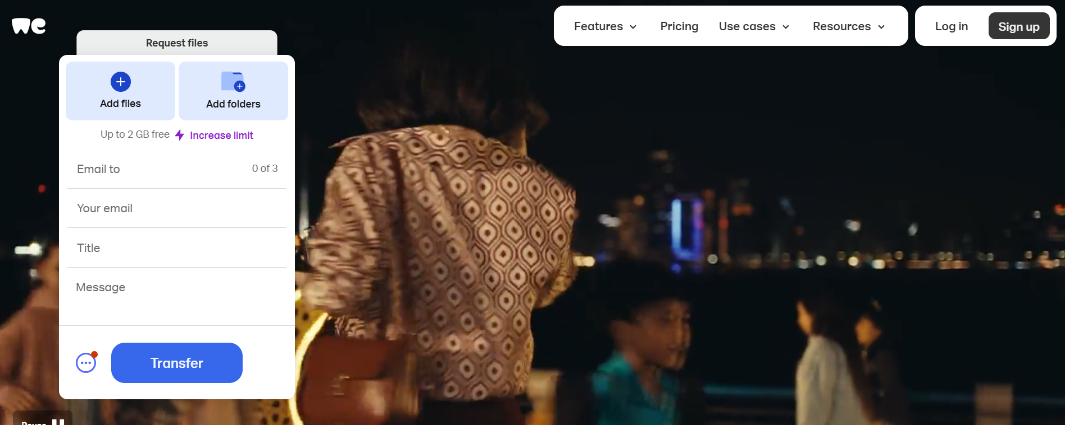
1.Email to - dick@drascombe.uk
2. Your email
3. Title – Your name and the boat name
4. Message – any message you want
5. Click on Add Files and navigate to the images/videos you have taken – make sure you select them all – up to 2GB – if more then send as many as you can and then repeat with second email.
6. Click on Transfer. You will get an email to say they have been sent, as well as one to say they have been opened.
We may not use all the images but it gives us a good library to choose from.

DP
Drascombe Boats Ltd

